Electric Field

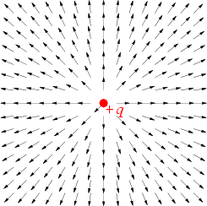
For a point charge q at position (i.e., an electric monopole), the electric field at a point r is defined in cgs to be
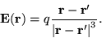 | (1)

In MKS, the corresponding equation is
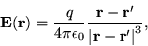 | (2)

where is a fundamental constant called the permittivity of free space. The electric field is therefore defined such that for an electric monopole, E points away from a positive charge and towards a negative charge.
For an arbitrary collection of charge, the electric field can be determined experimentally as
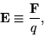 | (3)

where F is the force exerted by the field on a test particle of charge q.
For a static electric field E, the electric field is defined in terms of the electric potential (sometimes also denoted V and called the voltage) by
(4)

where is the gradient. In the presence of a time-varying magnetic field, the electric field is given in cgs by the differential form of one of the Maxwell equations,
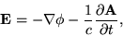 | (5)

with c is the speed of light and A is the magnetic vector potential. In MKS, the corresponding equation is
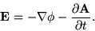 | (6)

For a continuous distribution of charge , the electric field at a point r is given in cgs by
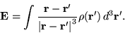 | (7)

In MKS,
